

|  |
| --- |
| **PROPOSAL** |

**Strengthening Village Forest License Management to Support Kubu Raya PPI Compact Targets on Emission Reduction**

|  |  |  |
| --- | --- | --- |
| **Contact Details 1** | | |
| Contact Name | : |  |
| Title | : |  |
| Organization | : |  |
| Address | : |  |
| Phone | : |  |
| Email | : |  |
|  |  |  |
| **Contact Details 2** | | |
| Contact Name | : |  |
| Title | : |  |
| Organization | : |  |
| Address | : |  |
| Phone | : |  |
| Email | : |  |

1. **BACKGROUND**

According to the Provincial Monitoring Report on GHG Emission (2020), deforestation in Kubu Raya in 2013-2018 reached 109,923 hectares[1], with an average of 18,320 hectares per year. The deforestation rate boosted by 208 percent upon the baseline (8.780 hectares per year). It is equivalent to 26,171 units of new soccer fields appearing every year. Taking these figures into the overall perspective of West Kalimantan Province indicates that Kubu Raya had the 2nd highest deforestation rates in the period 2013-2015. Deforestation has an impact on the proportion of the remaining forest cover area. The forest remains only around 30 percent or 260,548 hectares of the total district area in 2018[2].

Kubu Raya is also the second-largest emitter in the overall province for the period of 2013-2018. Emissions from deforestation, degradation, and peat decomposition accounted for 118 million tCO2e, with an annual average of 19 million tCO2e.

The main challenge in Kubu Raya is to shifting the paradigm in managing land-based business sectors. Referring to the deforestation data, land clearing activities and fires accounted for the largest deforestation of 57,534 hectares (52.34 percent), the large plantation sector covering 38,565 hectares (35 percent), the forestry sector covering 11,196 hectares (10.18 percent), the agriculture sector covering 2,545 hectares (2 percent), and 83 hectares (0.5 percent) came from the settlement (infrastructure)[3], fisheries, and mining activities. At the same time, those sectors are backbones for the District to grow its regional income. It contributes around ±44.4% of overall Gross Regional Domestic Revenue (GRDP)[4]. Therefore, Kubu Raya faces a severe challenge to achieving paradigm shift and sustainable development with the current pathway.

In 2018, the Government of Kubu Raya, with its partner support, including YIDH, has initiated jurisdictional initiatives to lower deforestation rates, increase forested areas and community livelihood. Those initiatives are i) develop a jurisdictional-level agreement, Protection Production Inclusion Compact (PPI Compact), with public and private sector involvements, ii) create long term Strategy and Action Plan on Green Growth of Kubu Raya (SRAK PPH)[5], which links to Provincial Green Growth Plan[6], and iii) initiate the Kubu Raya, Landscape Fund. YIDH is also preparing for a Verified Sourcing Area (VSA) pilot for Kubu Raya for specific palm oil and timber products. It is hoped Kubu Raya could go further for more sustainability in regards to their commodities production. In the field levels, forest protection, restoration, and livelihood improvement have been implemented under various supports, financial instruments, and stakeholders (private sector and communities) work together to achieve sustainability.

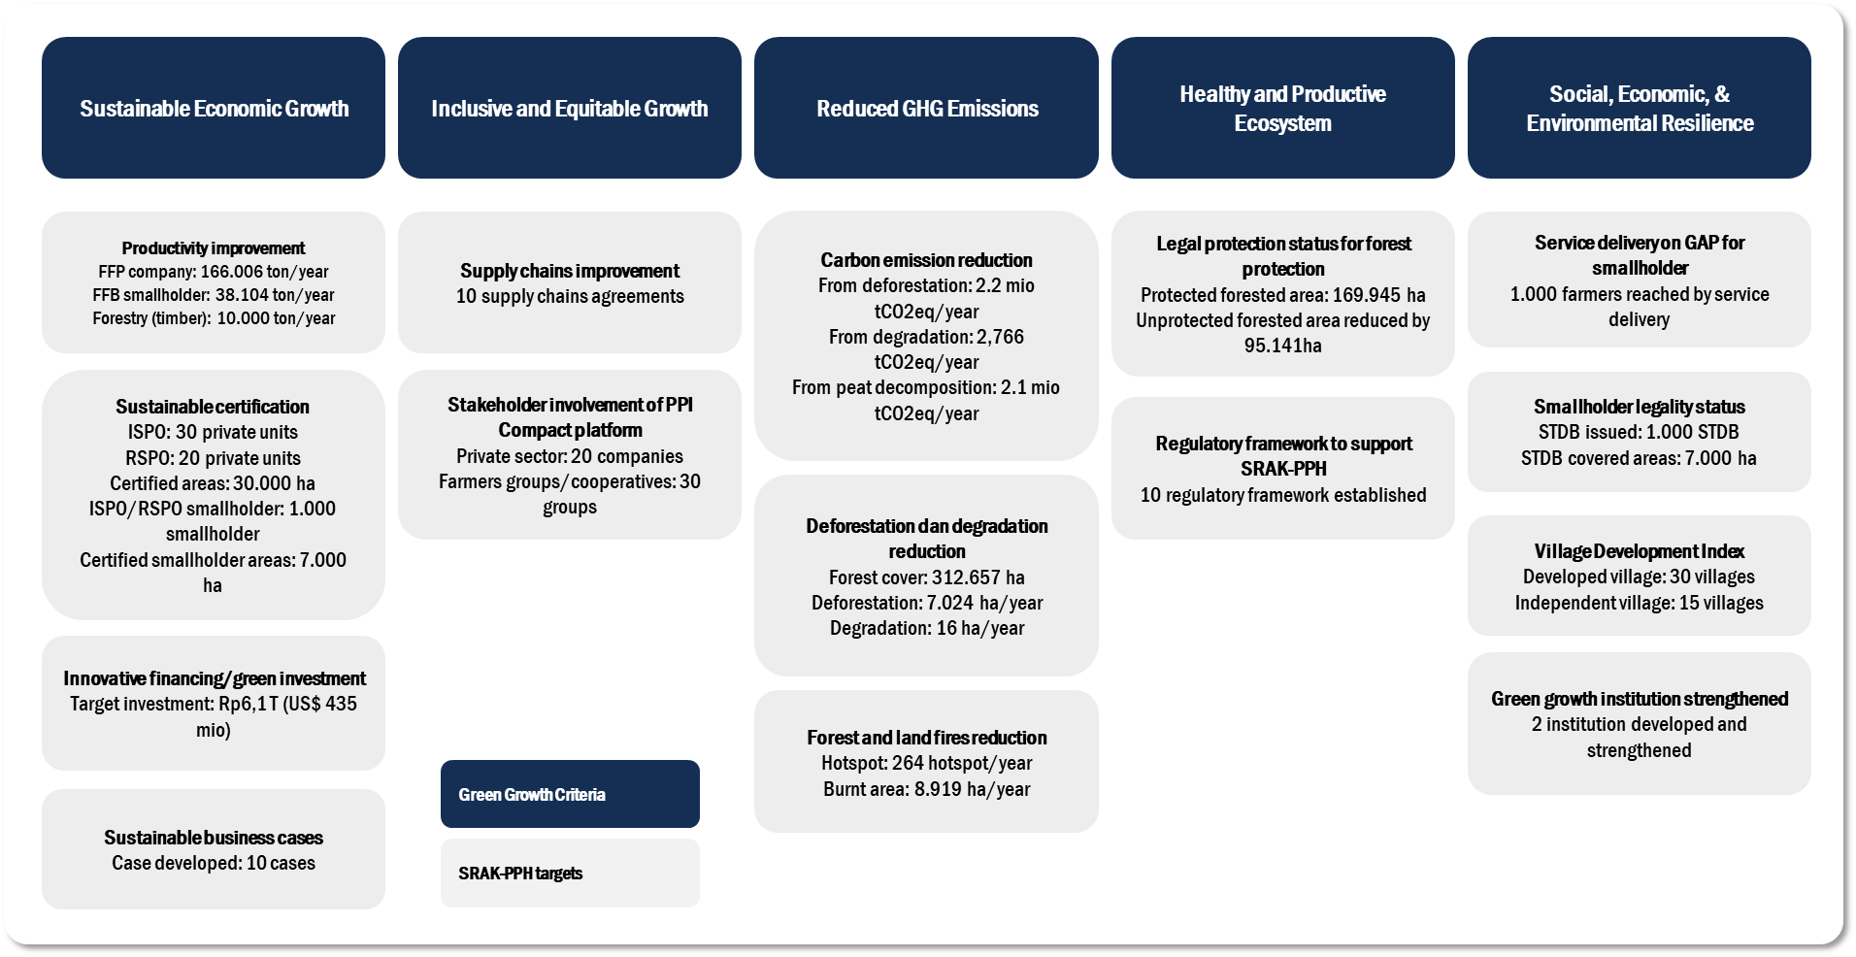

Figure 1. SRAK PPH Kubu Raya Targets

One potential project to support Kubu Raya's goals and targets on emissions reduction stated in SRAK PPH is community-based village forest[7] projects (part of the social forestry scheme). Kubu Raya has the largest village forest concession granted by the Ministry of Environment and Forestry (MoEF) in the province, covering about 106.363 hectares of license (30+ villages). The village forest scheme has the potential to advance forest protection, restoration, and livelihood improvement activities at the field level.

With the 35-year village forest license, communities are the key actor of forest management. They have robust legal support to protect their forest, space to select their livelihood improvement, optimize their village potentials, and, importantly, improve the site-level of forest management blended with their local knowledge and wisdom. Indeed, robust forest management plans, sustainable funding supports, institutional and human resources capacity, and networking are the key and needed to ensure both forests and communities could benefit from village forest projects.

However, communities face severe challenges in managing the license due to insufficient institutional and human resources capacities and funding resources to plan, perform, and monitor forest management plans and access to funding and markets. In 10 villages at Padang Tikar, Kubu Raya, communities showed they could lower deforestation rates by about 83 percent in the 3rd years after the license granted by MoEF. Still, they faced challenges in improving participation, institutional development, advancing their business model, and insufficient long-term funding support[8]. In addition to the internal challenge, communities face challenges in preventing the expansion of the agriculture field for key commodities such as palm oil, paddy, and infrastructure development, due to a lack of incentives for their forest protection activities and business model with high investment returns.

This project will strengthen village forest license implementation to avoid deforestation and community livelihood improvement, contributing to emission reduction targets stated in SRAK PPH Kubu Raya. This project targets ten villages in Kubu Raya. The goal will be achieved through three main objectives include forest protection and restoration, improving community livelihood by developing a robust business model and sustainable agricultural practices, and improving institutional capacity for 35-year forest management.

1. **PROPOSED PROJECT AREAS**

Detail proposed project areas are in the following table:

|  |  |  |  |  |  |  |
| --- | --- | --- | --- | --- | --- | --- |
| **No** | **Village Name** | **License Year** | **Village forest areas (ha)** | **Forest Cover (ha)** | **% of Forest Cover** | **Forest Type** |
| 1 | Ambawang | On process | 3.701 | 3.130 | 85 | Mineral and peat |
| 2 | Kampung Baru | 2019 | 827 | 448 | 54 | Peat |
| 3 | Sungai Bemban | 2020 | 1.315 | 1.239 | 94 | Mineral |
| 4 | Sungai Deras | On process | 1.009 | 551 | 55 | Mineral and peat |
| 5 | Dabong | 2017 | 2.770 | 2.092 | 76 | Mangrove and peat |
| 6 | Mengkalang | On process | 1.996 | 1.670 | 84 | Mangrove and peat |
| 7 | Mengkalang Jambu | 2019 | 2.921 | 1.847 | 63 | Mangrove |
| 8 | Selat Remis | 2019 | 573 | 198 | 35 | Mangrove |
| 9 | Seruat II | 2017 | 613 | 568 | 93 | Mangrove |
| 10 | Sui Nibung | 2017 | 3.149 | 2.158 | 69 | Mangrove |
|  | **Total** |  | **18.874** | **13.900** | **100** |  |

While deforestation and emissions profile at targeted villages is in the following table:

|  |  |  |  |
| --- | --- | --- | --- |
| **No** | **Village Name** | **Deforestation rate (baseline)**  **(ha)** | **Emissions from deforestation (baseline)**  **(tonCO2eq)** |
| 1 | Ambawang | 17,8 | 8.251,3 |
| 2 | Kampung Baru | 14,6 | 6.766,6 |
| 3 | Sungai Bemban | - | - |
| 4 | Sungai Deras | 14,1 | 6.528,6 |
| 5 | Dabong | 24,9 | 9.094,3 |
| 6 | Mengkalang | 11,7 | 4.176,8 |
| 7 | Mengkalang Jambu | 37,9 | 17.451,3 |
| 8 | Selat Remis | 6,2 | 2.216,4 |
| 9 | Seruat II | 0,9 | 435,7 |
| 10 | Sui Nibung | 30,4 | 10.879,7 |
|  | **Total** | **158,4** | **65.801,7** |

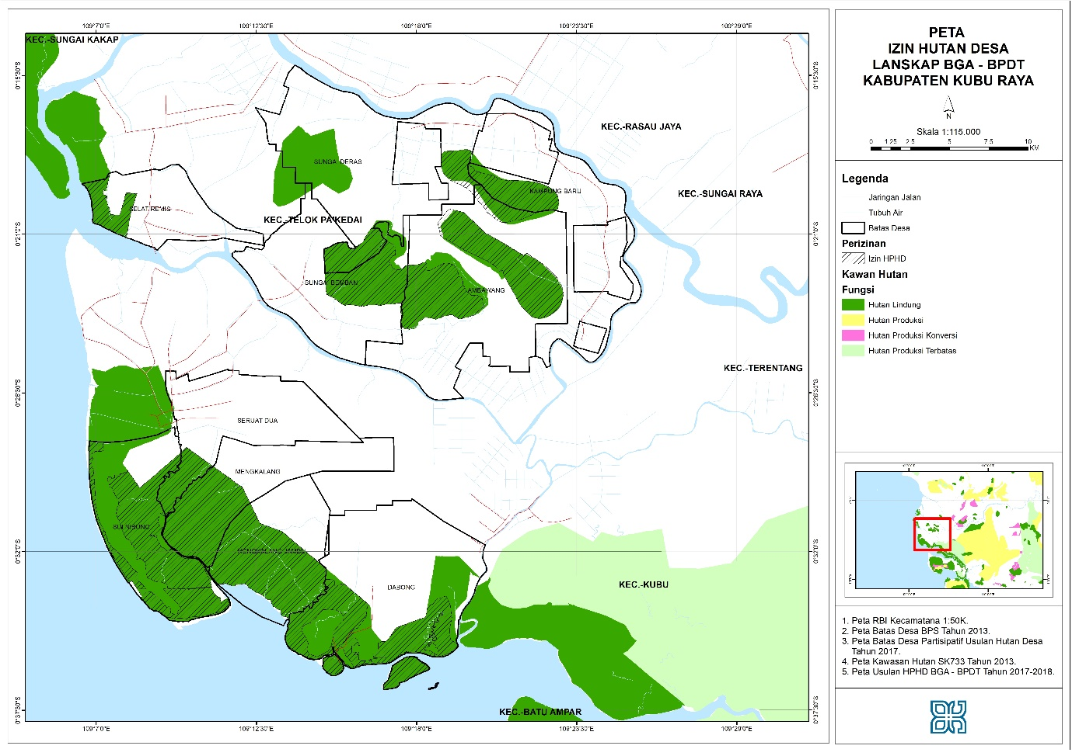

1. **PROJECT FRAMEWORK**

| **Objective** | ***Indicator*** | **Output** | ***Indicator*** | **Activity** |
| --- | --- | --- | --- | --- |
| **Objective #1:** To protect and rehabilitate forests within the village forest concession from deforestation and forest degradation | *# number of forests under protection efforts by community # number of endangered and endemic species (plants/animals) that are protected and conserved # number of degraded area covered by rehabilitation activity* | **Output #1:** Forest and its ecosystem within village forest concession are protected from the threat of deforestation and degradation (13.900 ha) | *# number of SOPs on SMART Patrol developed and agreed with communities # number of SMART patrol implemented per month by community # number of conservation plans for key endangered flora & fauna species developed* | 1.1. Mapping and marking the outer edge of village forest concession |
| 1.2. SMART Patrol implementation |
| 1.3. Support protection infrastructure needs and tools for community and maintenance |
| **Output #2:** Habitat of endangered plants and wild animals are conserved and enhanced with local wisdom approach | *# number of seed planted for feed enrichment for key endangered wild animals # number of training on biodiversity conservation* | 2.1. Identifying flora & fauna within the village forest |
| 2.2. Developing conservation plans for key endangered flora & fauna species within the village forest |
| **Output #3:** Degraded areas are rehabilitated by agroforestry approach (500 ha) | *# number of seeds planted within degraded village forest concessions or outside # number of mortality rates of seeds* | 3.1. Building seed nursery facility, seed planting, and nurse the planted areas |
| **Objective #2:** To improve community prosperity by improving forest-based economic values and sustainable agriculture practices | *# number of forest products developed as an alternative income for communities # number of business models developed for potential forest commodities # number of community applied sustainable and low emission agriculture practice* | **Output #4:** Robust and sustainable business models are developed as community alternative livelihood and income | *# number of training on business unit management and commodity production conducted # number of demplot developed for potential commodities* | 4.1. Feasibility study for potential and investable commodities |
| 4.2. Set up business units for potential commodities |
| 4.3. Training on business unit and commodity production |
| 4.4. Develop demplot for potential commodities |
| **Output #5:** Creative marketing system to promote business model and products developed | *# number of agreement with potential market/off-taker/financial institution to support business models # number of marketing system/platform developed # percentage of products sales* | 5.1. Engage with potential market/off-taker/financial support for business models |
| 5.2. Marketing on community products through online and offline media |
| **Output #6:**  Communities adopt best practice on sustainable agriculture for key commodity (palm oil) | *# number of training conducted on sustainable agriculture practices # number of demplot developed for sustainable agriculture practices* | 6.1. Training on sustainable and low emission agriculture in the village |
| 6.2. Support for demplot development for sustainable agriculture practices |
| 6.3. Improve sustainable supply chains of smallholders |
| **Objective #3:** To establish a robust village forest institution in leading 35 years of village forest license | *# number of institutional training and assistance conducted for LPHD # number of robust SOPs or village regulation on LPHD's institutional arrangement created* | **Output #7:** LPHD has the capacity to plan, implement, monitor, and evaluate the village forest plan | *# number of training conducted for LPHD & community on institutional, organizational, and programming aspects # number of the annual plan and long-term forest plan developed for the village forest license # number of annual institutional score & performance* | 7.1. Series of training on institutional building for LPHD and annual refreshment for institutional development & HRD |
| 7.2. Develop annual plans, implementation, & M&E of the village forest plan |
| 7.3. Coordination with key stakeholder for village forest license management |
| **Output #8:** Project management, coordination, monitoring, and evaluation | *# number of project coordination, monitoring, and evaluation with LPHD & community # number of activity recorded and publicized for public support and awareness # number of project reporting and annual impact assessment arranged* | 8.1. Ensuring the implementation of planned plans and budget |
| 8.2. Coordination, monitoring, and project reporting |
| 8.3. Knowledge management and publication |

1. **TIMELINE AND BUDGET**

The proposed project timeline is 36 months (3 years), and the indicative budget is EUR 3.810.000 with the detail following:

|  |  |  |  |
| --- | --- | --- | --- |
| **Objectives** | **Year 1**  **(EUR)\*** | **Year 2**  **(EUR)\*** | **Year 3**  **(EUR)\*** |
| **Objective #1:** To protect and rehabilitate forests within the village forest concession from deforestation and forest degradation | 520.000 | 520.000 | 520.000 |
| **Objective #2:** To improve community prosperity by improving forest-based economic values and sustainable agriculture practices | 240.000 | 240.000 | 240.000 |
| **Objective #3:** To establish a robust village forest institution in leading 35 years of village forest license | 310.000 | 310.000 | 310.000 |
| **Management Cost** | 200.000 | 200.000 | 200.000 |
| **TOTAL** | **1.270.000** | **1.270.000** | **1.270.000** |

*\*Note: the above budget is indicative. It is subject to changes*

1. **SCALING AND LONG TERM IMPACT**

This project will contribute to scalable intervention/business models and potential role models for overall village forest license management across the province and Indonesia. This means an efficient socio-economic increase or environmental impact from a small to a large scale of coverage (in terms of people and areas). Therefore, it is crucial to design a scaling strategy so that this project can provide meaningful outputs and outcomes as expected. Loreal supports can be used to accelerate the fundamental base for the impacts that aligned with the following:

* **Provincial targets on emissions reductions**

The Government of West Kalimantan (GoWK) revealed its pledge to avoid deforestation and degradation in 2012. In the following year, GoWK prepared its high-level policies and frameworks, including Regional Action Plan on Green House Gas Emission (currently being revised), the complimentary of jurisdictional REDD+ strategies and plans for guiding the REDD+ implementation in the land-based sector, and sectoral reforms to support the REDD+. GoWK pledged ambitious targets for 60% emissions reduction by 2030 and 4.7% for Nationally Determined Contribution (NDC).

WK’s 60% targets for emissions reduction from deforestation is 13.2 mtCO2/year (emission level is 22.1 mtCO2eq per year). While in Kubu Raya, the emissions reduction target is 20% or 814,046 tonCO2/year of GHG emission reduction, according to SRAK PPH Kubu Raya. It notes that it will contribute to 6.3% of the Provincial target on emission reduction from deforestation.

**Therefore, this project will reduce emissions reduction for around 8% of Kubu Raya emissions reduction from deforestation (814,046 tonCO2/year).**

* **PPI Compact and Verified Sourcing Area (VSA)**

A Compact is a multi-stakeholder agreement to address sustainability challenges in a coordinated, time-bound, and resource-committed manner across a sourcing area. The Compact includes time-bound sustainability goals and describes how these will be achieved. It also lists sustainability KPIs that will be monitored by Compact stakeholders and/or external parties. Finally, it includes Projects in an investment pipeline to achieve the sustainability goals set.

Verified Sourcing Area (VSA) is currently being developed in Kubu Raya to create reliable linkages between the stakeholders inside and outside the producing areas and supply chains, backed by relevant, accurate, and verified data. In Kubu Raya, the PPI Compact was signed in 2019 by the District Government of Ketapang and IDH. The collaboration will ensure that all targets of sustainable palm oil production, protection of forest areas, and improving the welfare of independent smallholders and local communities will be achieved. This collaboration and progress will be monitored and governed through a multi-stakeholder secretariat consisting of government, private sector, and civil society representatives.

As for the Kubu Raya, they are supported by the strong commitment of district government and private sectors such as Asia Pulp and Paper (APP), Sumitomo Group, KPN Plantation, PT EKL, and PT KLIA to transform Kubu Raya supply chains. The District could lead the way to become the next VSA. From the market side, several buyers have indicated their interest to explore potential collaboration. However, major challenges lie in the absence of platforms, frameworks, and governance structures to accommodate this commitment. Furthermore, there is a critical need for securing off-take and financial commitment to de-risk and accelerate project implementation. A concrete action to address deforestation and transform the palm oil supply chain in Kubu Raya will be built in 2021 through PPI Compact and field-level project implementation covering technical assistance for oil palm smallholders, forest protection, and community livelihood.

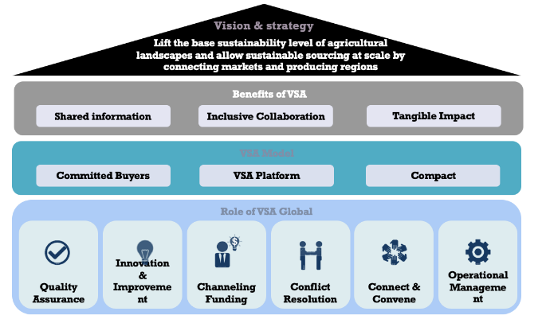

Figure 1. VSA approach to link Jurisdiction with Markets

While VSA serves as a platform, directly connecting markets and producing areas on their sustainability priorities. The VSA model relies on five key elements: 'the Compact', 'Committed Buyers', 'Enablers', 'Investors' and an 'Online Platform'. For its stakeholders, the VSA model has three key value propositions: shared information, tangible impact, and inclusive collaboration. IDH is currently preparing a VSA online platform globally named SourceUp. It has a beta model for Kubu Raya that can be accessed under <https://sourceup-fe-prod.azurewebsites.net/compacts/kubu-raya>.

* **Scaling for Investment Pipelines**

IDH has broad experience in financing and impact investment, especially for sustainable landscape and key commodities. We see this as a crucial component for creating impact at scale and long term. There are several fundings that IDH manages and collaborates with. The funding can be used in Indonesia and are very active in looking for investment pipelines in West Kalimantan and Kubu Raya. The funding includes:

* + &Green.Fund <https://www.andgreen.fund>
  + Agri3Fund <https://www.idhsustainabletrade.com/landscapes/agri3-fund/>
  + Farmfit Fund <https://www.idhsustainabletrade.com/farmfit-fund/>
  + LDN Fund <https://www.idhsustainabletrade.com/news/land-degradation-neutrality-ldn-fund-makes-first-investment-towards-sustainable-land-management/>

1. **GENDER MAINSTREAMING**

Gender equality is crucial for this project since village forest licenses are managed by local communities (male and female). We will pay more attention to women's participation in the training by applying different IDH Gender Toolkit strategies.

This project will strategically address this challenge by taking several measures: (i) providing equal opportunity for women to participate in this initiative's decision-making processes meaningfully. We will implement affirmative policy to ensure that at least 30% of participants of the training to be delivered for women; (ii) we will ensure that the IDH Gender toolkit on Gender will be integrated into project implementation, monitoring, and evaluations as part of our commitment to advance Gender mainstreaming in the Jurisdiction. Specific attention will be given to the impacts of forest governance models promoted through this works to gender relations, equal opportunity and access of women and men to forest and land resources management, and possible risks of the program to the underlying gender relation and dynamics.

1. **IDH CAPACITY**

IDH receives funding from multiple European governments, including the Netherlands (BUZA), Switzerland (SECO), Denmark (DANIDA), and Norway (NICFI). It convenes public-private partnerships, balancing the interests of governments, CSOs, and companies. YIDH creates a common language and understanding of issues. The engagement of IDH with the private sector has led to co-investment and potential in scaling up their interventions to support the field level projects related to agriculture and landscape.

As a global organization, IDH has strong track records in implementing social and environmental standards in landscape related works. There are policies and guidelines regarding the jurisdictional approaches' social and environmental standards, including the International Corporate Responsibility (ICRS) policy.

Regarding monitoring and reporting, IDH has developed the Result Measurement Framework (RMF) approach to measure project output and its impact, where YIDH has adopted it for program implementation in Indonesia. The framework has three result areas – change in business practices, improved sector governance, and enhanced field-level sustainability to making the impact. They are captured in Key Performance Indicators (KPIs) collected by conducting field visits, focus group discussions, and workshops. Also, the project will also refer to the Coalition of Action reporting requirements to ensure compliance, consistency, and sufficient reporting against the funding framework.

In compliance aspects, this project will be audited by an external party. It will also provide space for any technical and substantial complaints regarding the project implementation process. The project will set up a specific contact address for any complaints coming to the project, and a form will be provided. Detail mechanism of compliance will be developed at the initial project stage.

**Additional relevant information:**

* [Verified Sourcing Area/SourceUp](https://www.idhsustainabletrade.com/approach/sourceup/)
* [IDH West Kalimantan Landscape](https://www.idhsustainabletrade.com/landscapes/west-kalimantan/)

1. **FUNDING ARRANGEMENT**

IDH will manage Loreal's funding to be channeled to project activities conducted by local partners such as Bentang Kalimantan as a leading facilitator of those village forest licenses (<http://bentangkalimantan.org/>). The mechanism consists of processes to solicit proposals, contracting processes, monitoring, and reporting FA implementations. We also have a Letter of Assignment (LOA) mechanism for direct output activities by consultants.

1. West Kalimantan GHG Performance Report 2013-2018, 2020 (<https://bit.ly/3iPgFUp>)
2. Idem
3. Idem
4. Kubu Raya Statistic, 2019 (<https://bit.ly/3lmqGZw>)
5. Link download <https://bit.ly/32AG8ej>
6. Link download <https://bit.ly/3krXArJ>
7. Village forest is community based forest management scheme. It is administratively granted by Ministry of Environment and Forestry to village government at state forest to be managed for 35 years.
8. Nurdwiansyah D, Hardiansyah G, Roslinda E. 2020. *Management Strategy for 10 Village Forest Permits in Padang Tikar Landscape to Avoid Deforestation.* Thesis S2, Tanjungpura University. Pontianak